**AWS Assignment day 11 & 12**

**Task 1: Working with SNS**

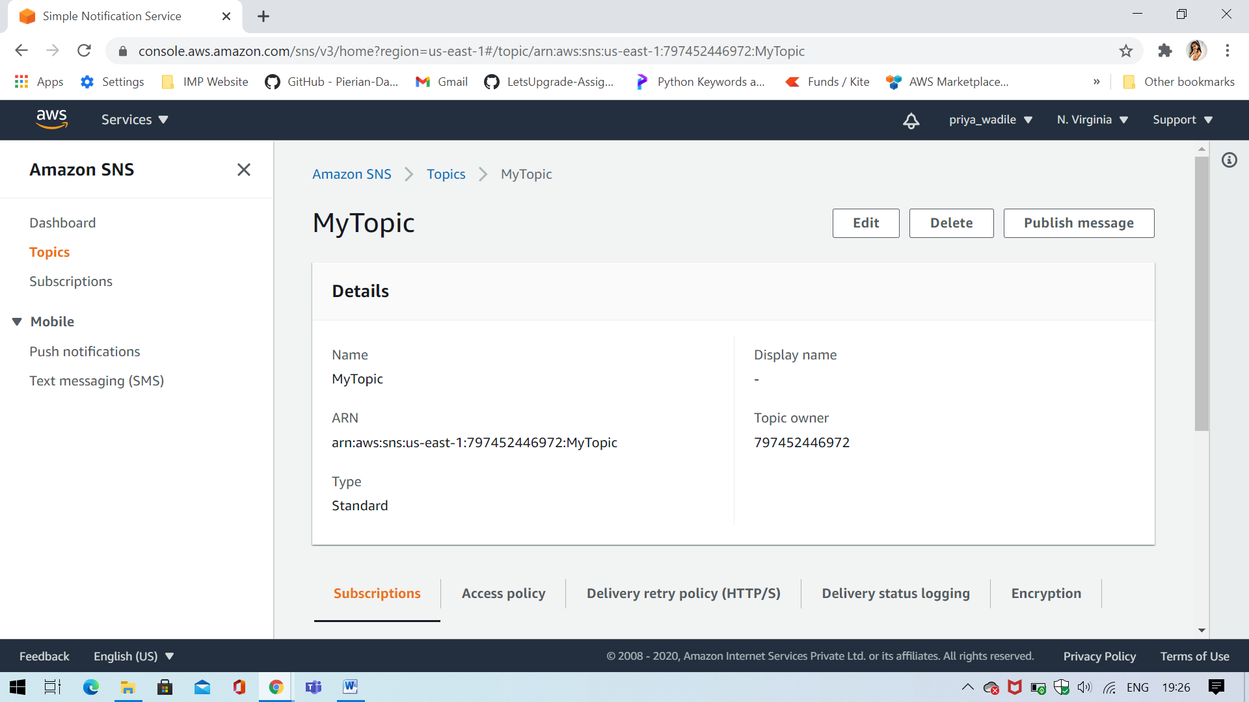

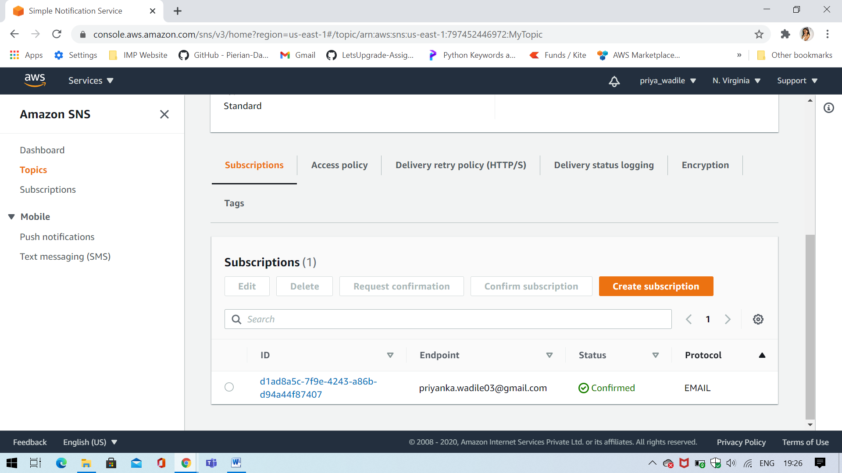

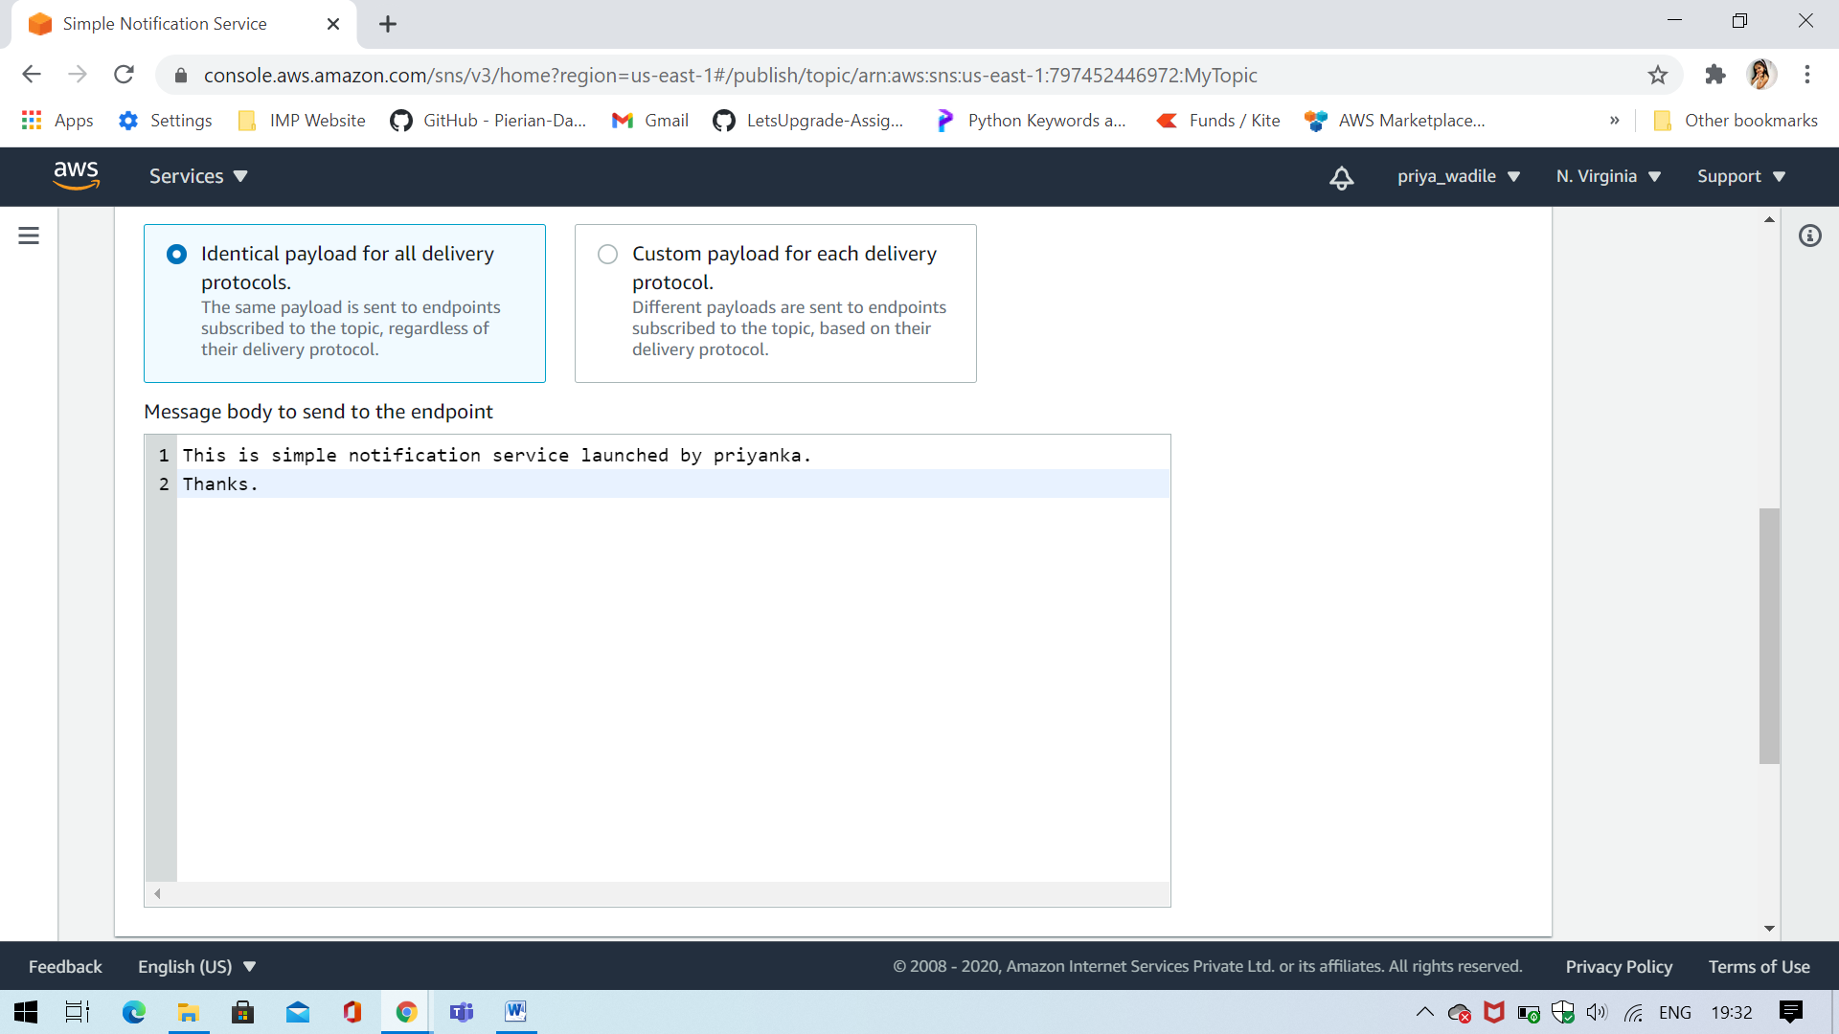

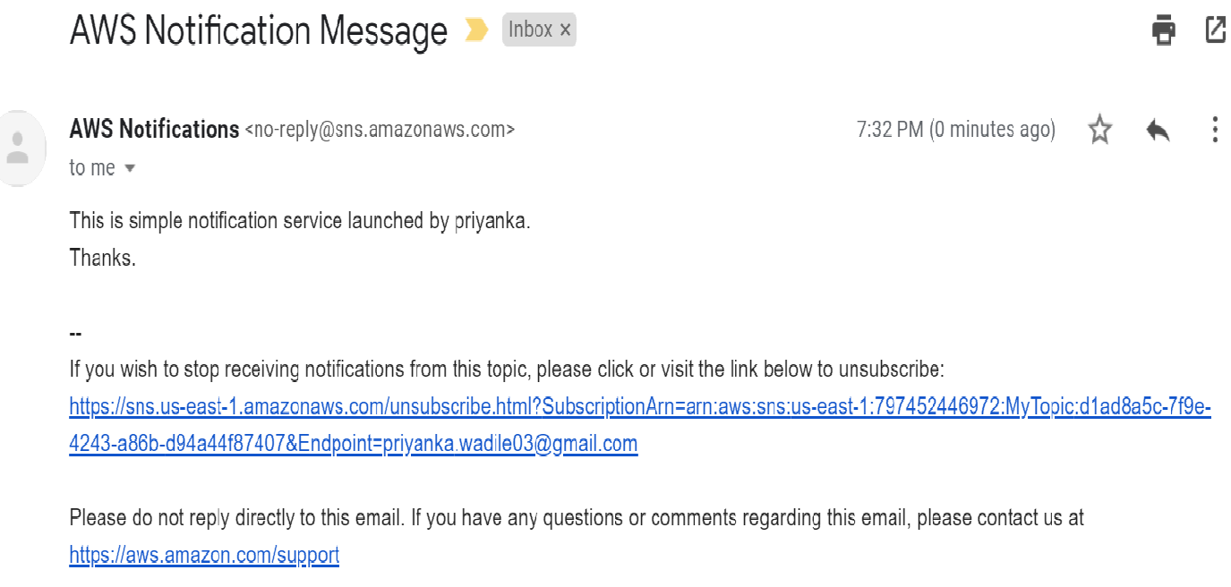

**Task 2: Working with SQS**

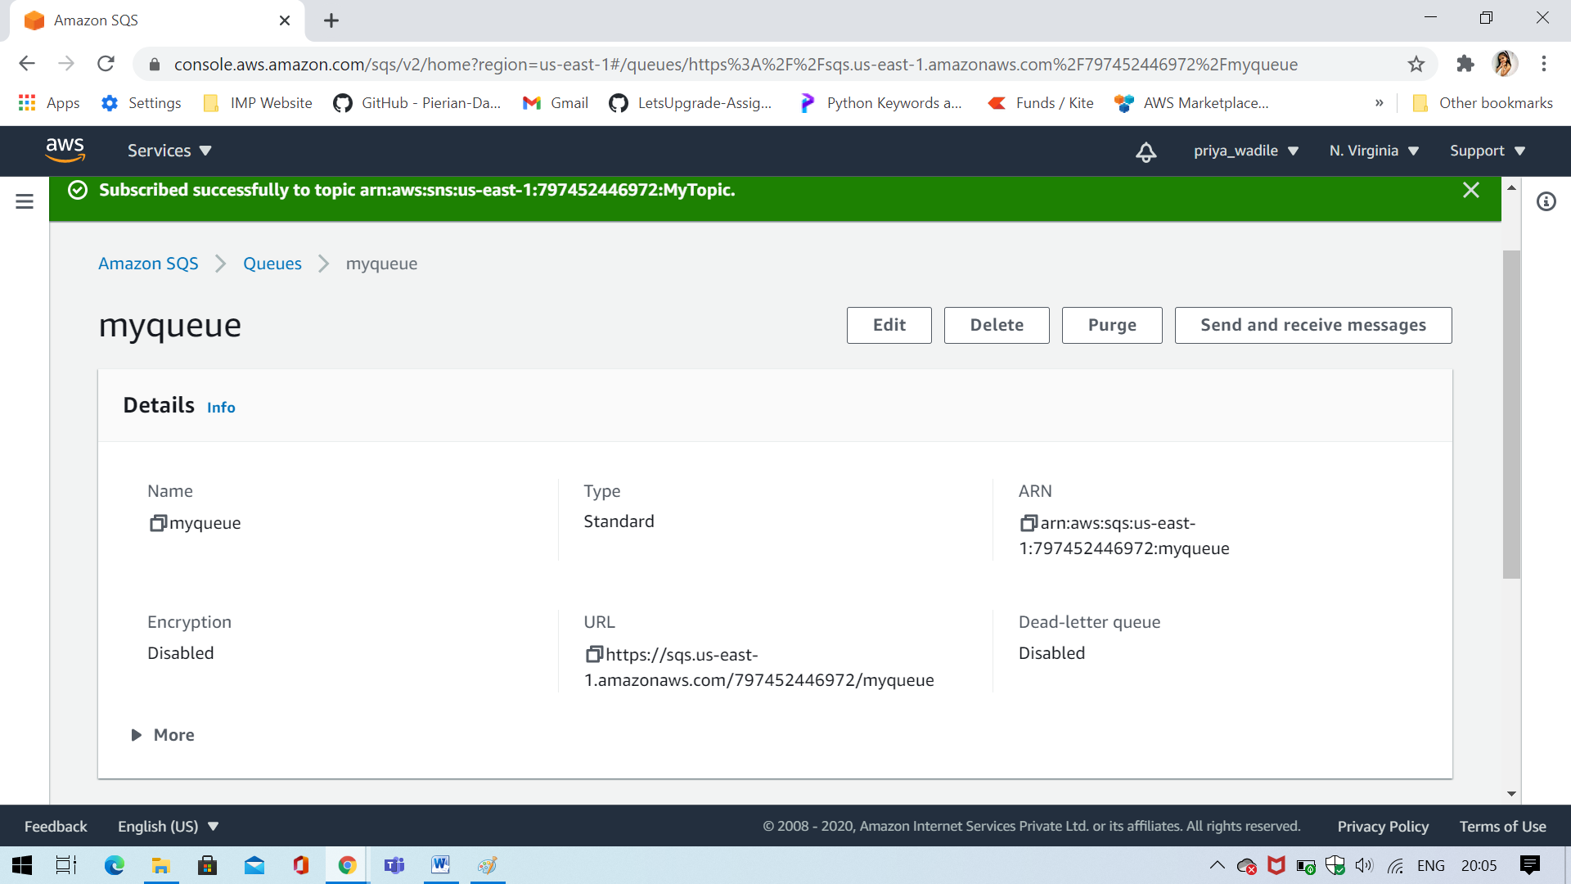

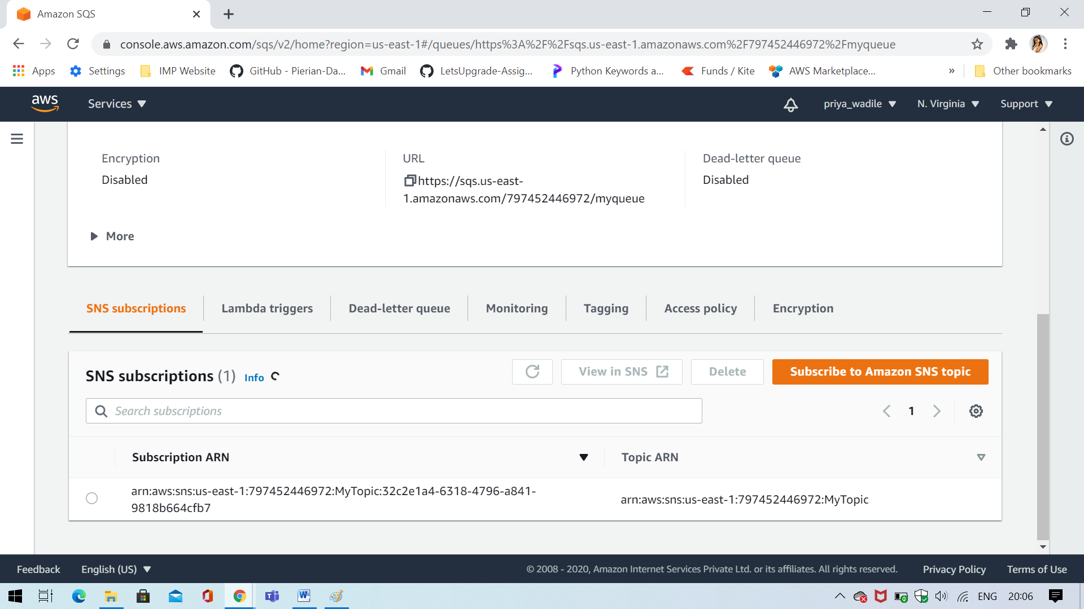

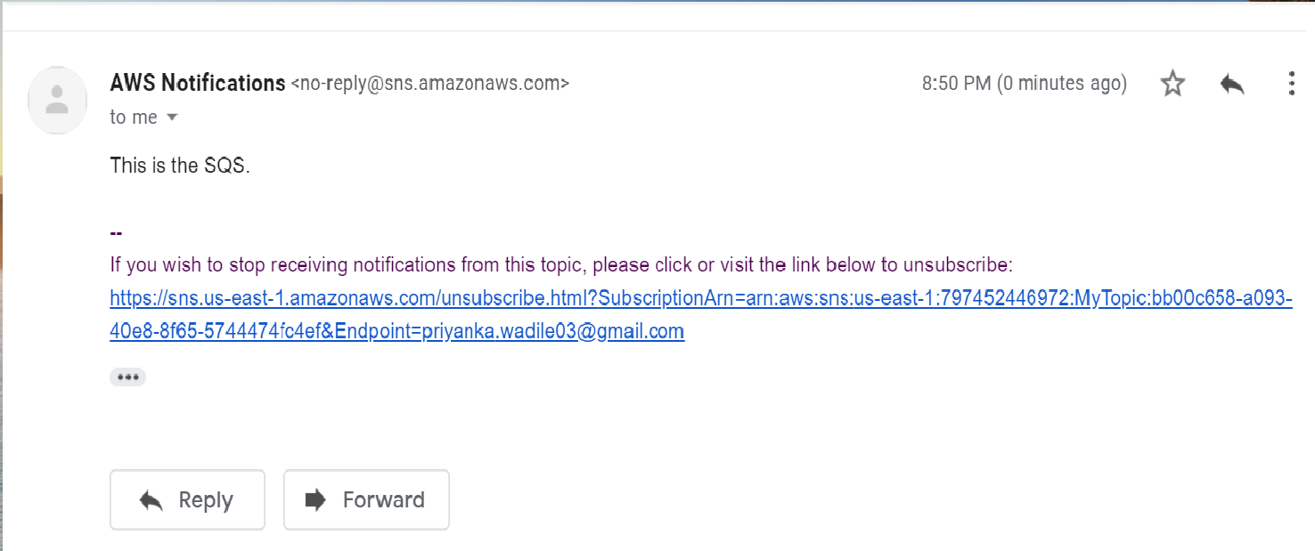

**Task 3: Working with SES**

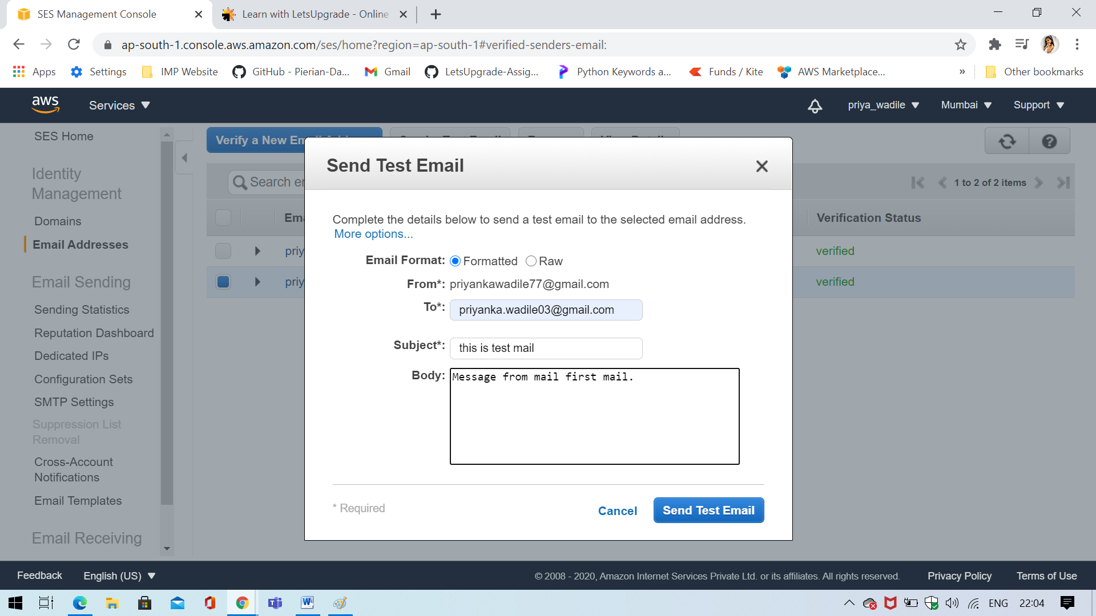

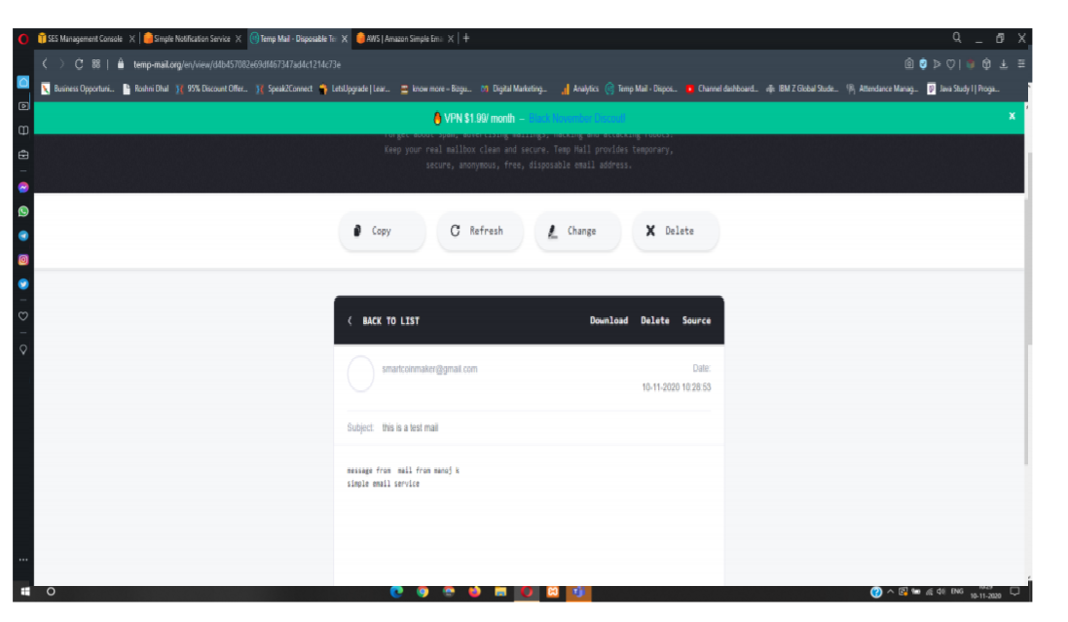

**Task 4:TRIGGERING CLOUDWATCH EVENT SNS NOTIFICATION**

**(Trainer mentioned that Task 4 is Optional during the lecture. Due to the reason that it includes the CloudWatch.)**

**Day 12 – Project**

**Task 1: Create a dynamo db table with minimum two disaster recovery zones and verify replication.**

**ss1: Disaster recovery regions with the table**

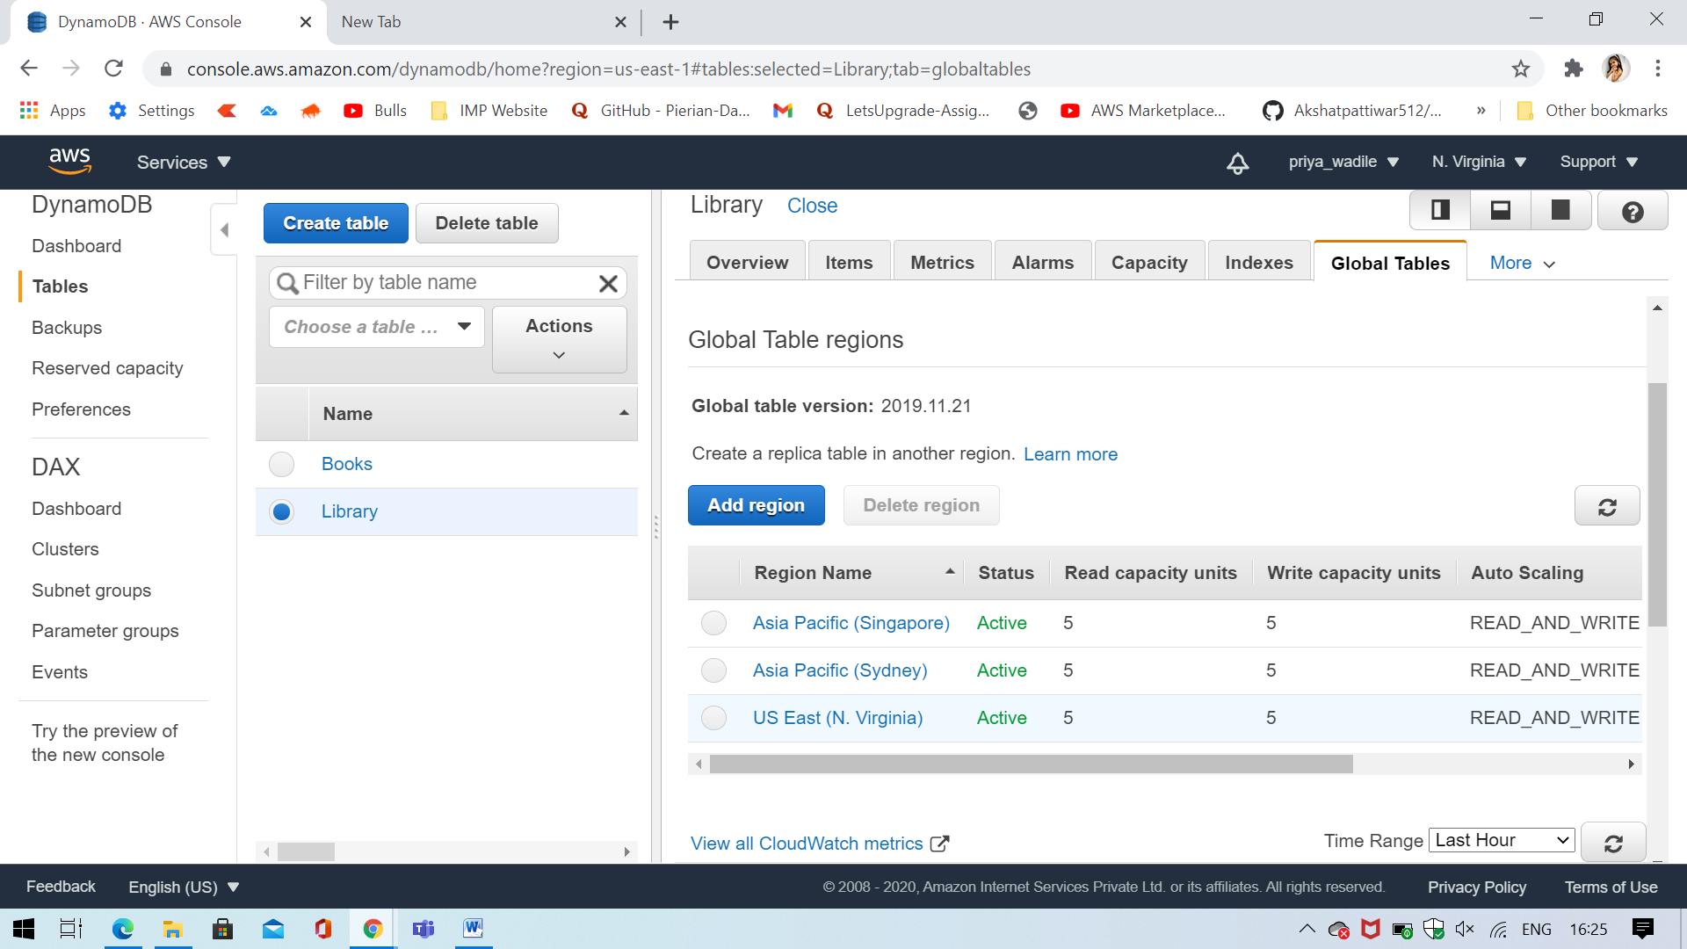

**ss2: Home region with all items displayed**

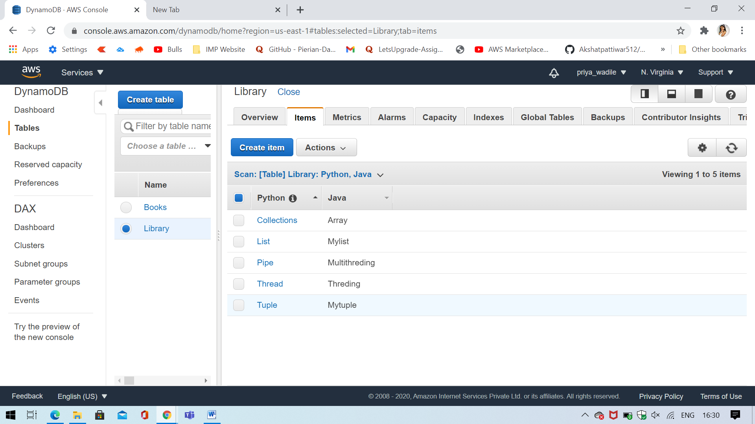

**ss3: Use query to fetch few items**

**ss4: deletion and verification**

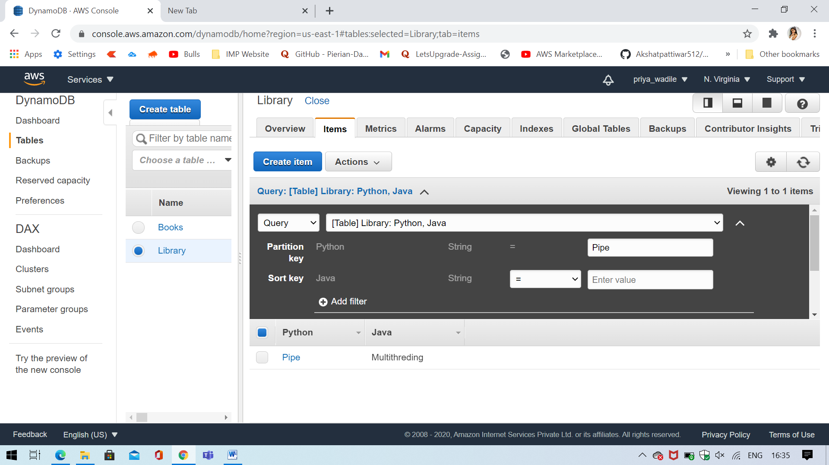

**Task 2: Creating a dynamo DB table with global secondary indexes and fetching data using global secondary indexes.**

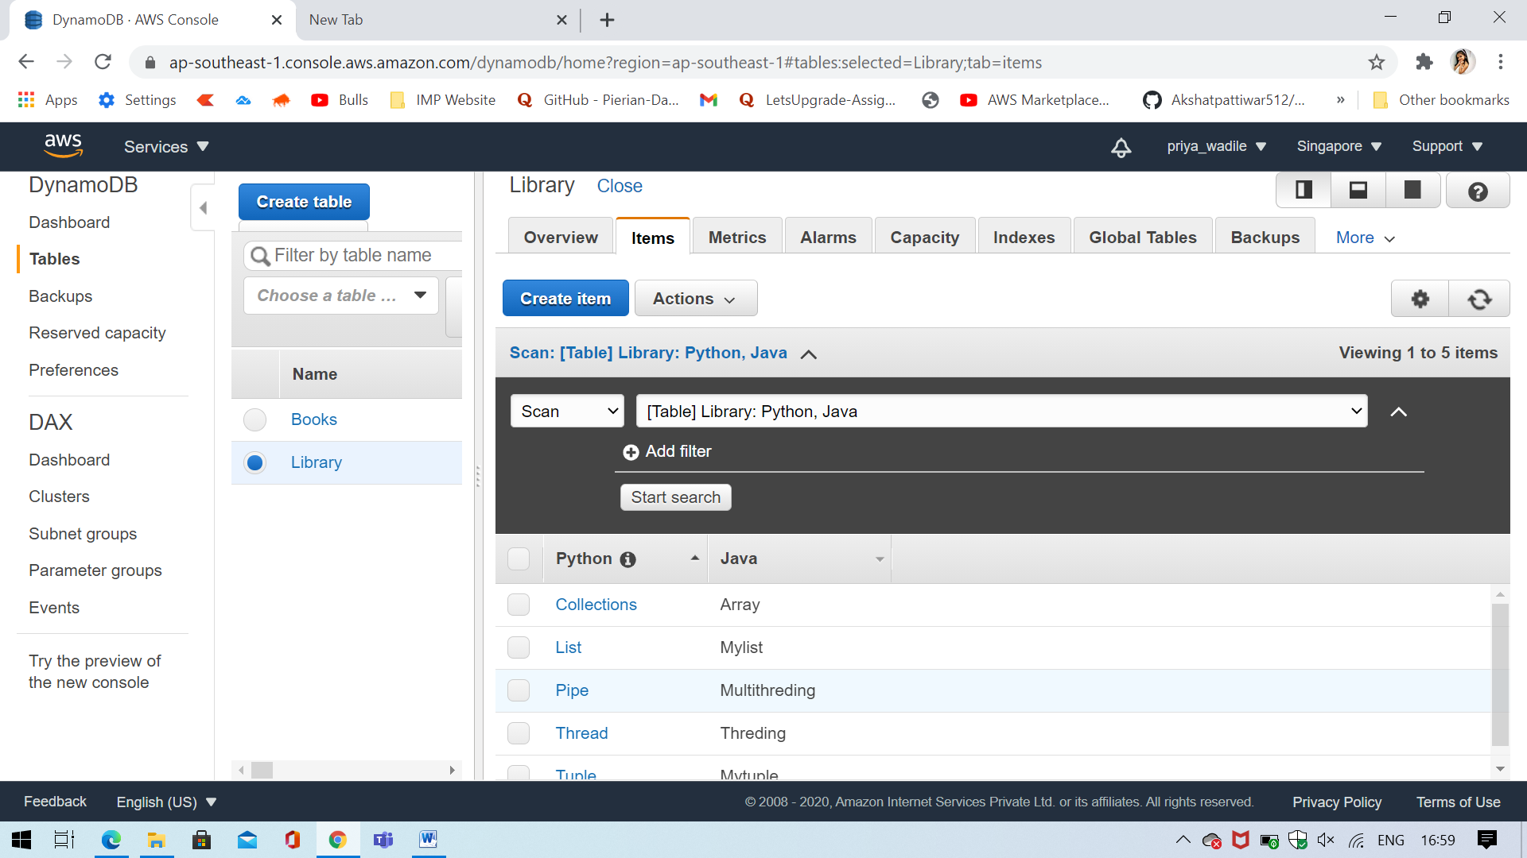

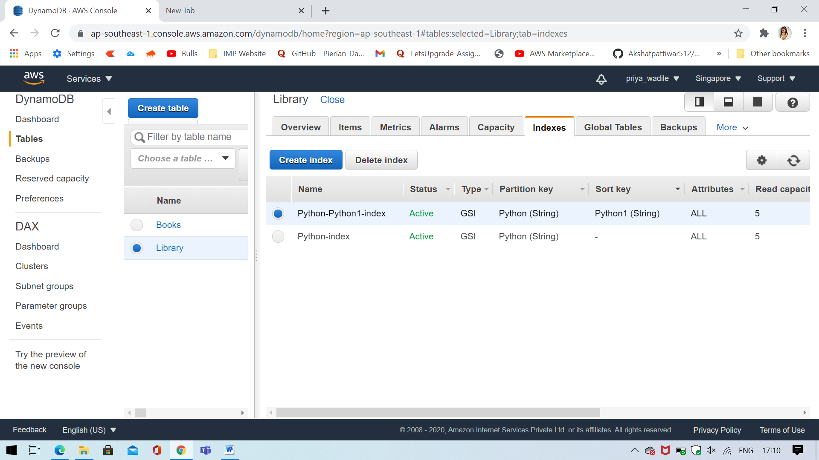

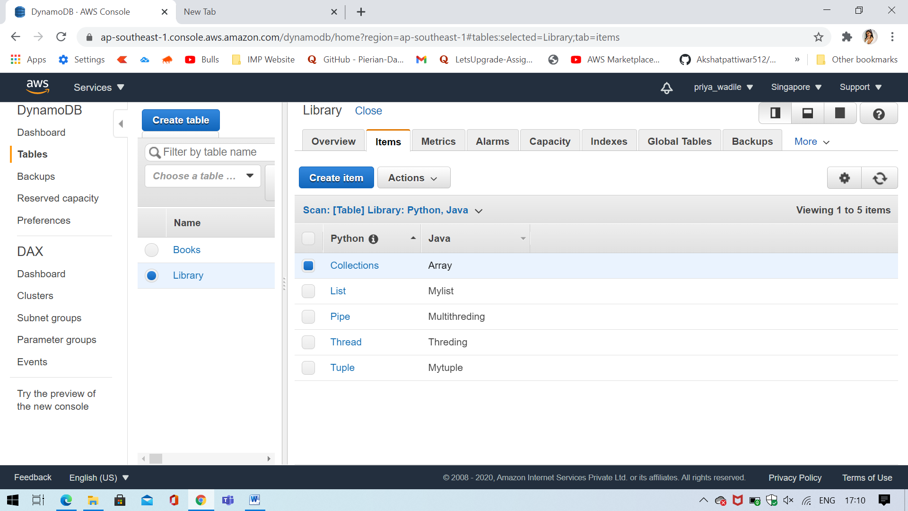

**Task 3: Deploying a python application in elastic beanstalk**

**ss1: Application page**

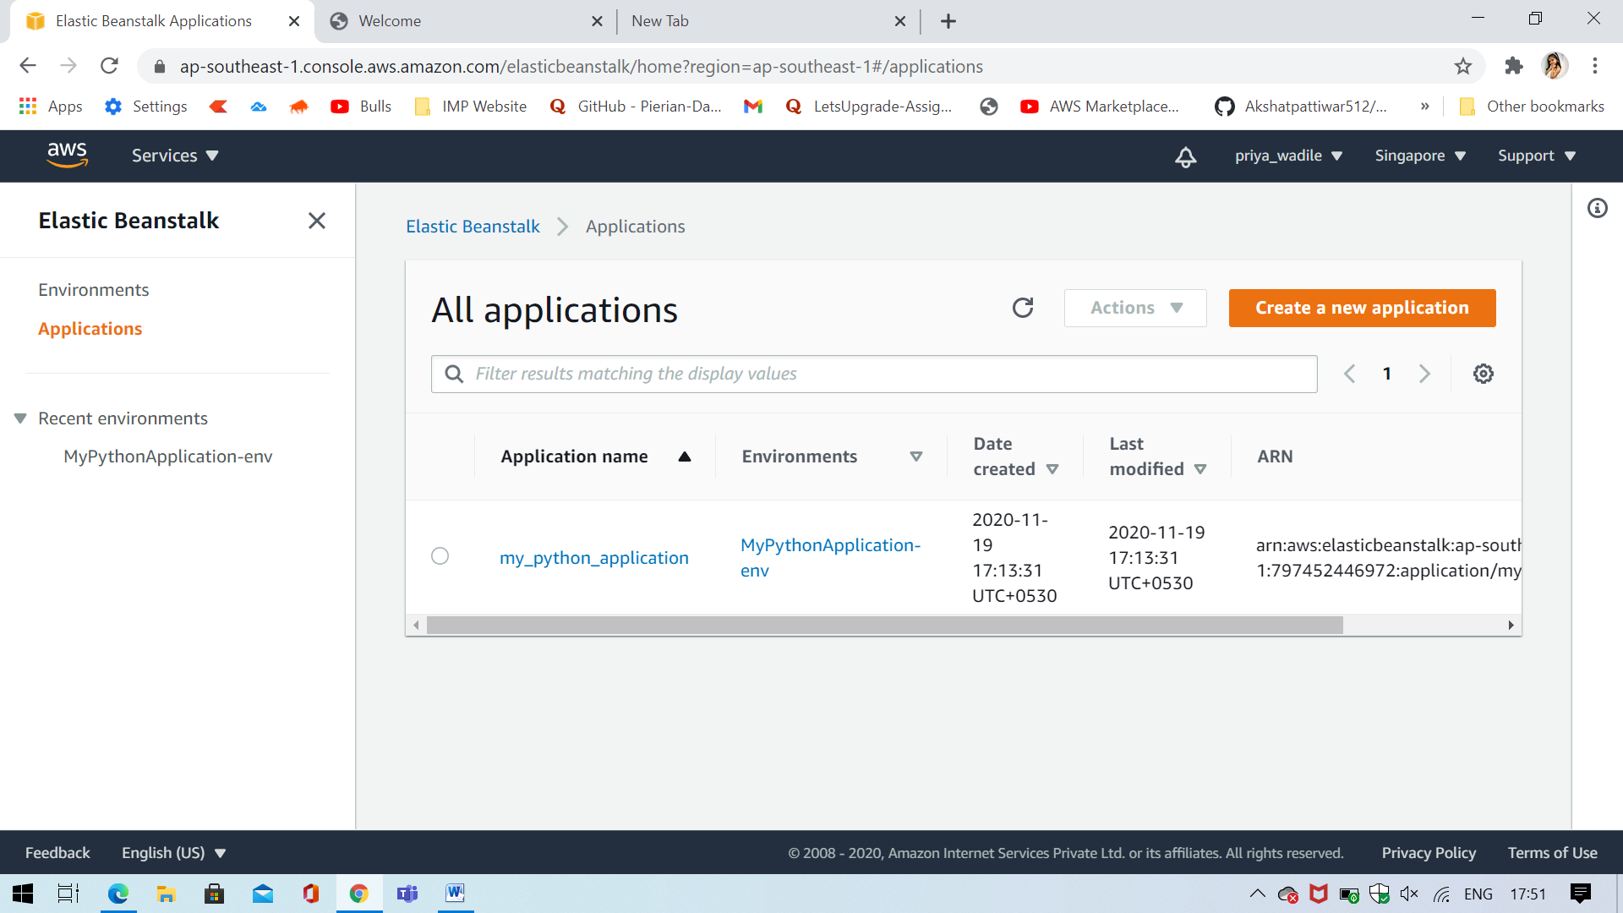

**ss2: env list page**

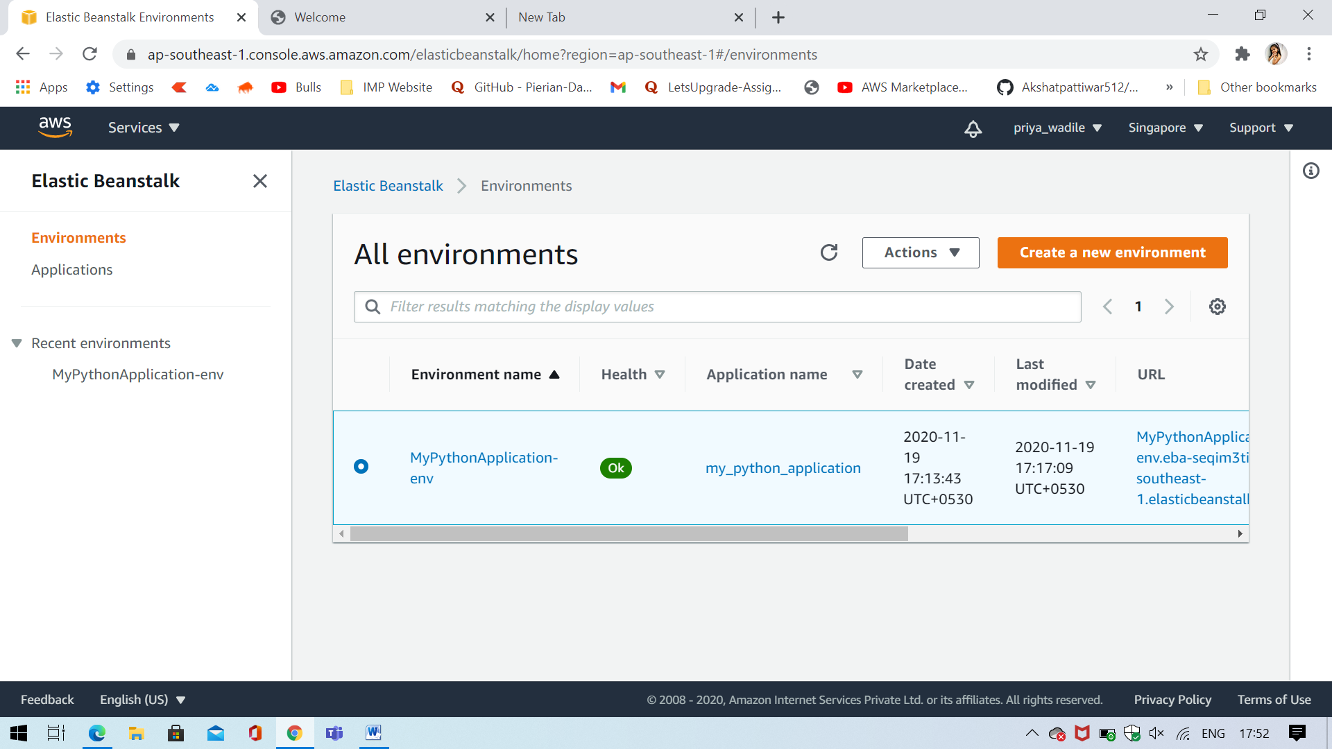

**ss3: env health status page**

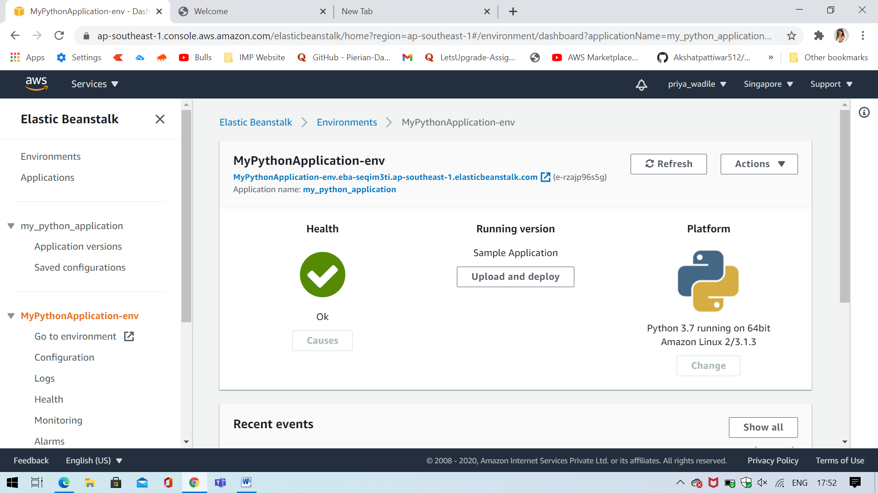

**ss4: Web page launched using the elastic beanstalk env**

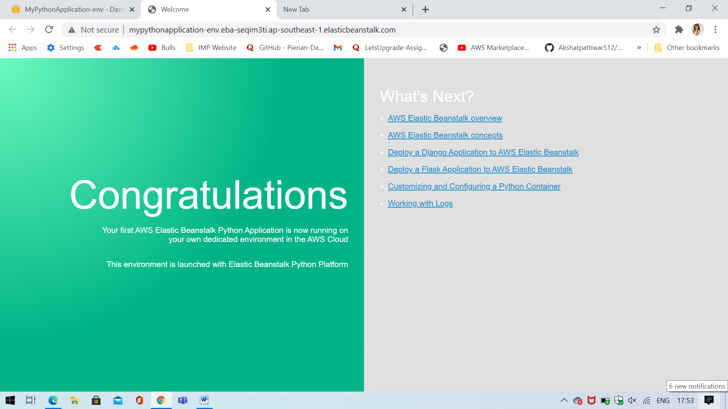

**Question 2: Submitted this as an Assessment Project - 1, as per the instructions of the Trainer. (In assignment submit form selected Project-1 for this submission)**